Go to https://franciscanathome.com/fortworth and scroll down until you see this:

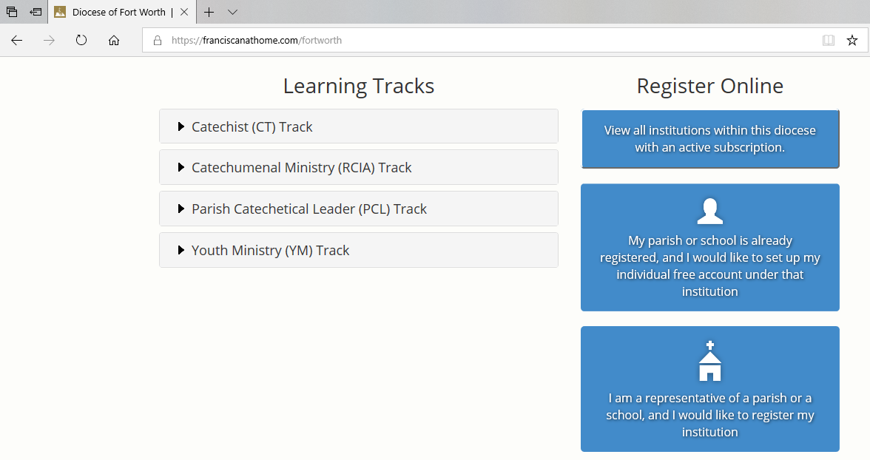
Click on this option

And follow the steps to create your account! Make sure you select St. Martin de Porres Catholic Church, Prosper as your parish

